Australia Coral Bleaching Report

ZHIYIN WANG

*Data wrangling*

*The original data source in the excel is unformatted. To input the data into tableau and perform visualization analysis, the data needs to be reformatted before any further exploration.*

*Wrangling process:*

*The data is entered separately under different coral types. In consideration of further analysis, all years columns need to be integrated into one new column. The integration of the “year” columns in excel is achieved by creating a pivot table containing all variables and then transform the data from wide format into long format. Furthermore, a new column named “coral types” needs to be created. It will contain all coral types and matches with every bleaching values. Thus, for each value, a coral type is indicated, the column is created to help data filtering and comparisons in further analysis. The column can be created manually as the new dataset is well ordered by coral types.*

*Dataset input into tableau after data wrangling is shown in figure 1.*

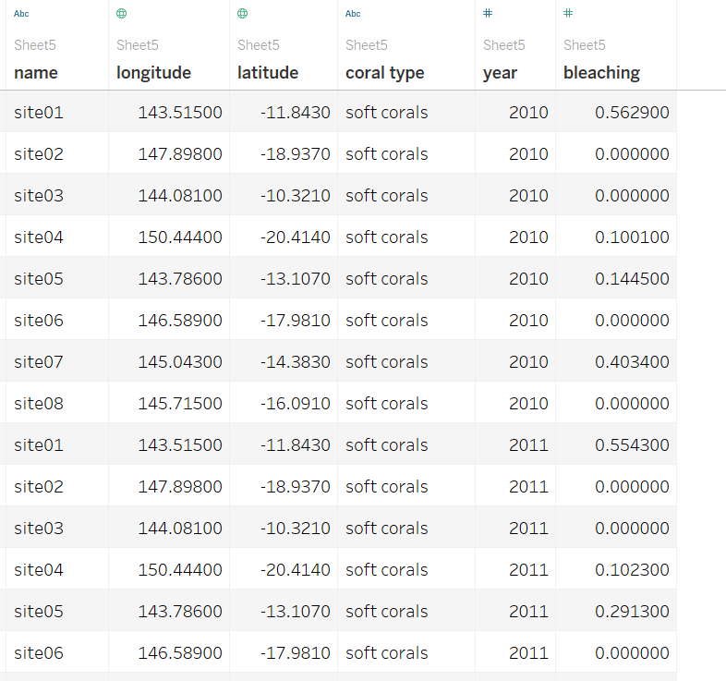

*Figure1. brief overview of dataset*

*Data exploration*

*After performing a few visualizations on the dataset, the following errors were* found.

*A entry error was found where one of site02’s location is wrong. As shown in figure 2, the latitude is entered as positive 18.94 which should be negative.*

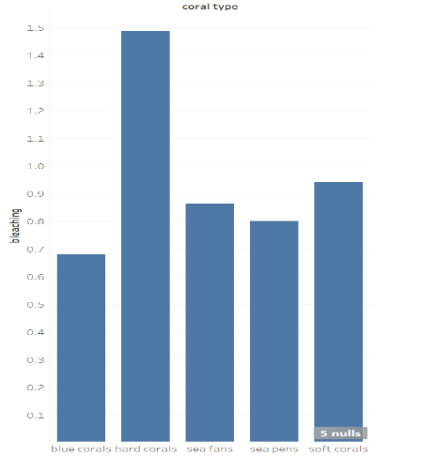*Another entry error was found by graphing the maximum bleaching of corals (figure 3), where one of the bleaching values are over 100%. The error is corrected by adding one decimal places before the value.*

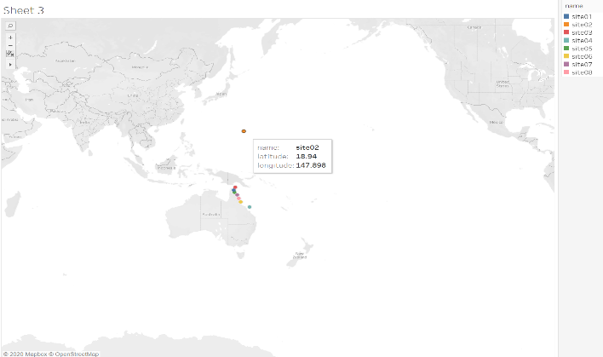

*Figure 2. location error (entry error) Figure 3. bleaching over 100% (entry error)*

*The bar chart in figure 4 shows that some data is null value, this indicates that some coral types didn’t exist in particular sites. After further investigation into the dataset, for some corals on a site, it has a null value in 2010 and has a measured bleaching value in later years. This may indicates that in 2010 there was no bleaching of those corals. Thus, all null values will be replaced by zero in the visualization analysis later on.*

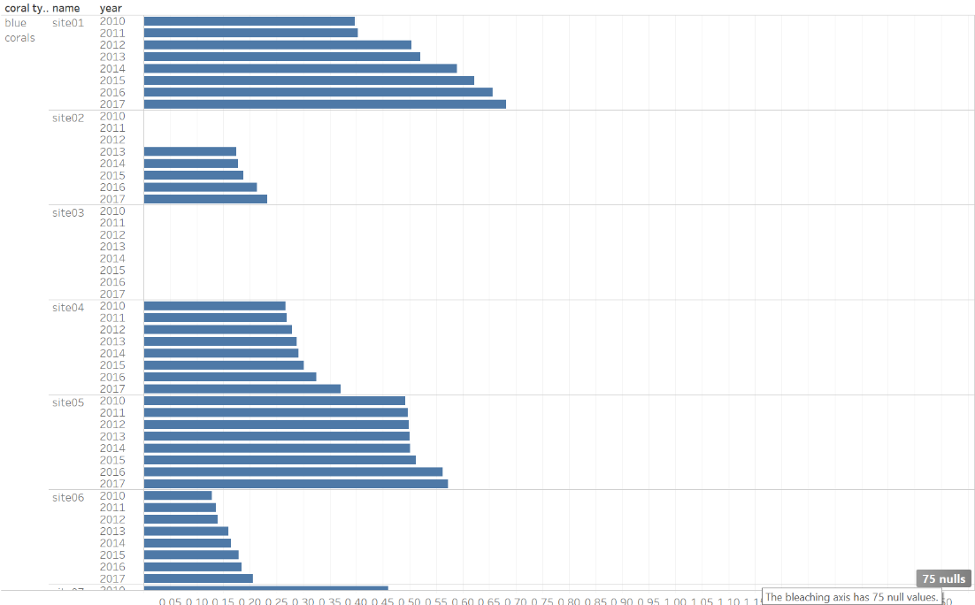

*Figure 4. bar chart shows null/missing values.*

*Visualization analysis & Questions*

***Q1) In which years and for which kinds of coral is bleaching the worst?***

*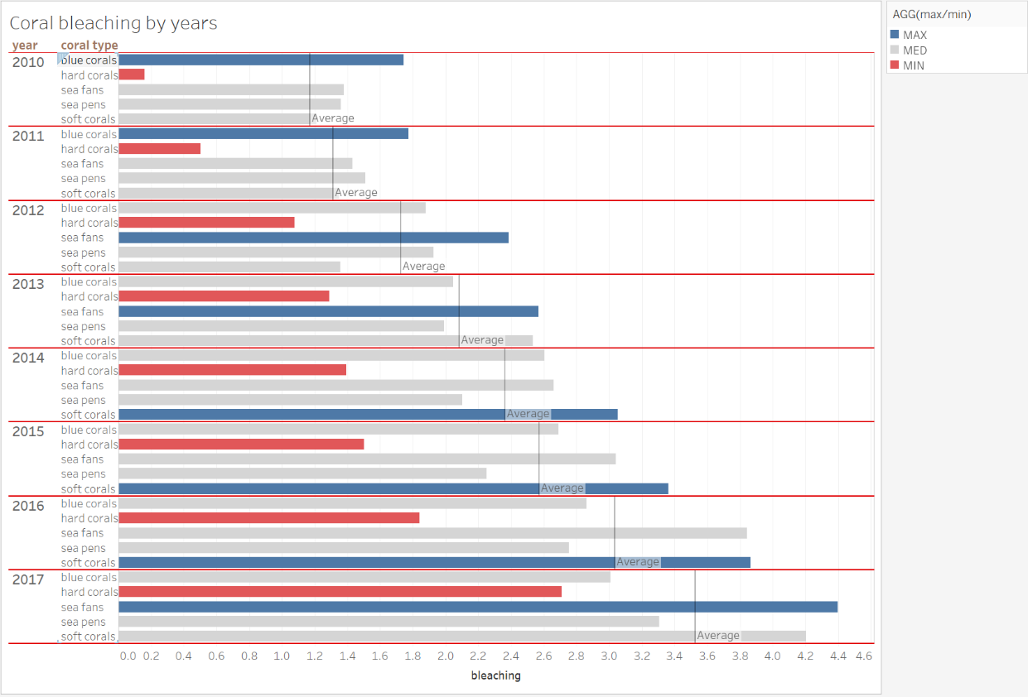Figure 5 shows all coral types bleaching across 2011 to 2017. The bar chart demonstrates which coral type is bleaching the worst in total measured from all sites. It clearly that coral bleaching has an increasing trend over the years as the average total bleaching amount is increasing constantly by years. In 2010 and 2011 blue corals have the highest bleaching amount in total. From 2012 to 2013, sea fans became the worst bleaching coral type. However, soft corals replaced its position from 2014 to 2016 and by 2017, sea fans again became the coral type that is bleaching the worst in total. On the other hand hard corals have the lowest bleaching amount over the seven years, being the most healthy coral type.*

*Figure 5. corals bleaching by year & type (Question 1)*

***Q2) How does the location of the site affect bleaching of the different kinds of corals?***

*Corals are bleaching to different extents in different locations. Figure 6 demonstrates an overview of coral bleaching on the eight sites of Australia by different coral types. Soft corals bleaching the worst at site05 and overall have worse bleaching on the north sites. Hard corals are bleaching badly on the one of the northern sites (site03 – 71%) as well as a 68% bleaching at southern site04. Sea pens and Sea fans appears to be bleaching worsen on the southern sites (site06, site02 & site 04) compared to other corals. However, 75% of Sea fans are bleaching on site 03 as well. On the other hand, blue corals have no bleaching on site03 but a 68% bleaching on site01 which is just below site03. Overall, from figure 7 it is clear that there is at least one type of corals bleaching over 50% on each site.*

*In comparisons, site07 and site08 has relatively less coral bleaching and site03 is the worst with three different coral types bleaching over 50%.*

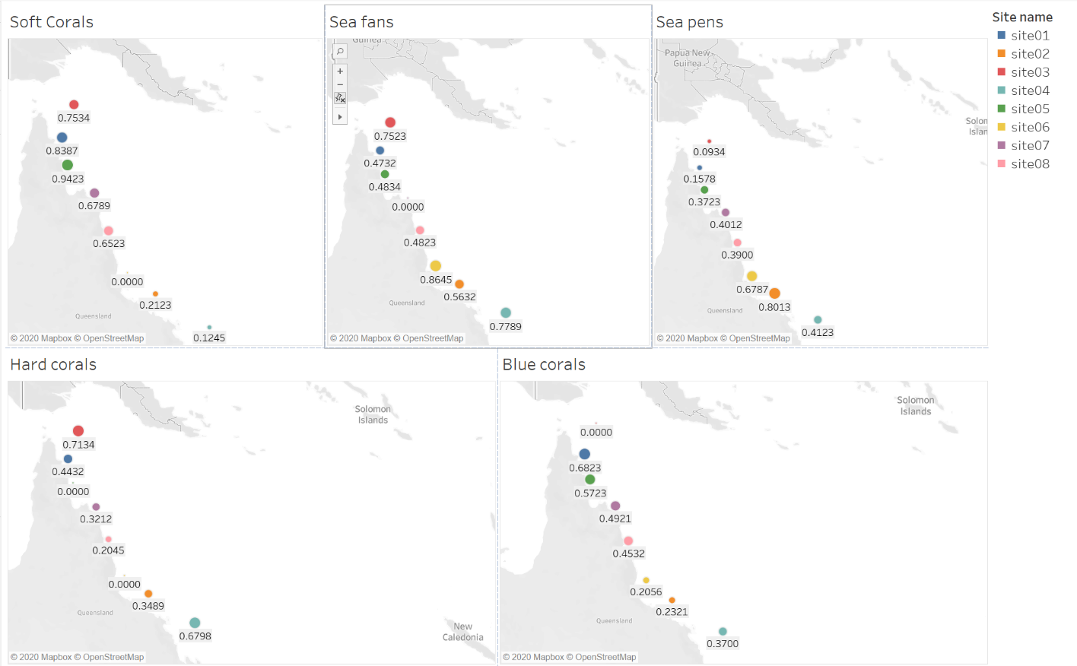

*figure 6. Bleaching map (Question 2)*

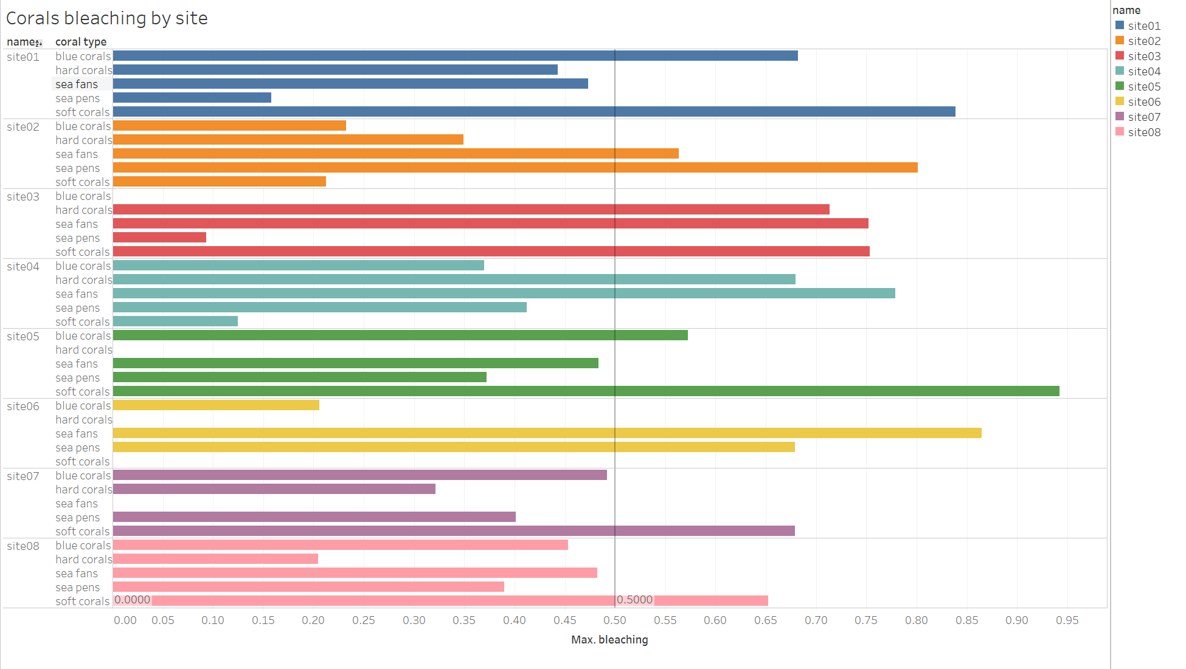

*Figure 7. bleaching by site (Question 2)*